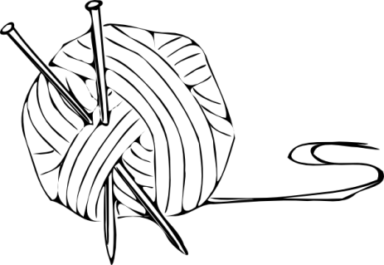 ___ $10 dues attached ___ Already a member
North Central Washington Knitters Guild

www.ncwknittersguild.com

Membership Form

A Guild membership provides you with a monthly meeting to enjoy the fellowship of other knitters, a monthly email newsletter, access to the Guild library, and learning opportunities/workshops throughout the year.

Tell us about yourself and your knitting!

Today’s Date
Name
Mailing Address
City, State, Zip
Home Phone |  | Cell Phone
Email
*Ravelry Name
*Facebook Name

*Optional: You may choose to add this information to our shared document (visible only
to approved members of NCW Knitters Guild Facebook group), if you want our members
to locate you on Facebook or Ravelry.

I enjoy knitting: (check as many as apply)

____ Scarves ____ Sweaters ____ Socks ____ Lace
____ Bags ____ Hats ____ Accessories ____ Cowls
____ For Men ____ For Baby ____ For Children other:____________
____ Afghans ____ Home Décor ____ Dishcloths __________________

I consider myself:

____ a real rookie
____ a confident beginner
____ of mixed confidence; good at some elements; not so good others
____ intermediate-advanced; pretty good at most things
____ at least a “9½” can take on any project

Bring this form/dues to any meeting on the first Tuesday of every month, 6pm, at the Wenatchee Eagles, 1208 N Wenatchee Ave) or mail to NCWKG, PO Box 2851, Wenatchee WA 98807-2851.

